User manual

Calcules®



*by PyJaMa’s*

20.4.2021

# Description

**Calcules** is a simple desktop calculator used to compute simple mathematical operations, such as addition, subtraction, division, multiplication, exponentiation, finding the root, factorial and goniometric functions.

# Disclaimer

Read this manual before using our software. Do not try to change any of the source code, as it may cause undefined behaviour or even dysfunction of this product. Team PyJaMa’s is not responsible for any troubles caused by previously mentioned actions.

Index

Description 2

Disclaimer 2

Installation 4

Running the calculator 4

User interface 4

Help button 5

Display 5

Clear & Delete 5

History 5

Number input 5

Operands 5

Addition ( + ) 5

Subtraction ( - ) 5

Multiplication ( * ) 5

Division ( / ) 5

Exponentiation ( ^ ) 5

Root 5

Square root ( √ ) 5

N – root ( n √ ) 6

Factorial ( ! ) 6

Parentheses ( () ) 6

Goniometric functions 6

Sine ( sin ) 6

Cosine ( cos ) 6

Tangent ( tan ) 6

Cotangent ( cotan ) 6

Uninstallation 6

# Installation

#to-do#

## Running the calculator

#to-do#

# User interface

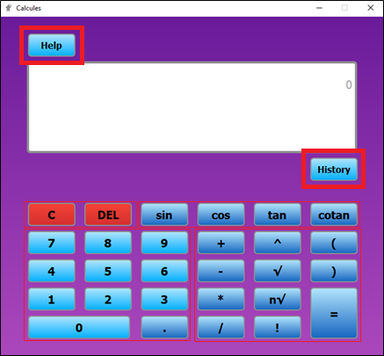

Help button Exit button

Display

History

Clear & Delete

Goniometric functions

Number input Operands

## Help button

Clicking on the help button pops out a window with basic information about proper manipulation with calculator.

## Display

Display shows all inputs, outputs and errors.

## Clear & Delete

Clicking on **C** (with mouse or via keyboard) clears all input.

Clicking on **DEL** (with mouse or via keyboard – BACKSPACE ) clears last input.

## History

Clicking on the history button pops out a window with the history of your previous calculations since opening the calculator.

## Number input

After clicking on a number input button, the desired number (or floating point) will be shown on display. You can also type in numbers and floating point / comma via keyboard

## Operands

After clicking on an operand button, the desired operation will be shown on display.

### Addition ( + )

Computes the sum of two given numbers. Usage: **numbe**r + **+** + **number**.

### Subtraction ( - )

Computes the difference between two given numbers. Usage: **numbe**r + **-** + **number**.

### Multiplication ( * )

Computes the multiple of two given numbers. Usage: **numbe**r + **\*** + **number**.

### Division ( / )

Computes the portion of two given numbers. Usage: **numbe**r + **/** + **number**.

### Exponentiation ( ^ )

Computes the exponentiation a number (exponent must be a natural number. Usage: **numbe**r + **^** + **number**.

### Root

#### Square root ( √ )

Computes the square root of a positive number. Usage: **√** + **number**.

#### N – root ( n √ )

Computes the n-th root of a positive number. Usage: **number** + **√** + **number**.

### Factorial ( ! )

Computes the factorial of a natural number. Usage: **numbe**r + **!**.

### Parentheses ( () )

Parentheses are used to determine the order of operations or when counting with negative numbers.

NOTE: You can also type in operands **+, -, *, /, !, √, ^, (,** and **)** via keyboard.

## Goniometric functions

Usage**: function** + **number** + **)**

### Sine ( sin )

Computes a sine value of a following number.

### Cosine ( cos )

Computes a cosine value of a following number.

### Tangent ( tan )

Computes a tangent value of a following number from R−{(2k+ 1)π/2;k∈Z}.

### Cotangent ( cotan )

Computes a cotangent value of a following number from R−{kπ ;k∈Z}.

# Uninstallation